**LAB 12**

*Inline Assembly*

**Q1) Write a program in C++ which takes input from user and contains a procedure in assembly named GCD which calculates their GCD.**

**Program:**

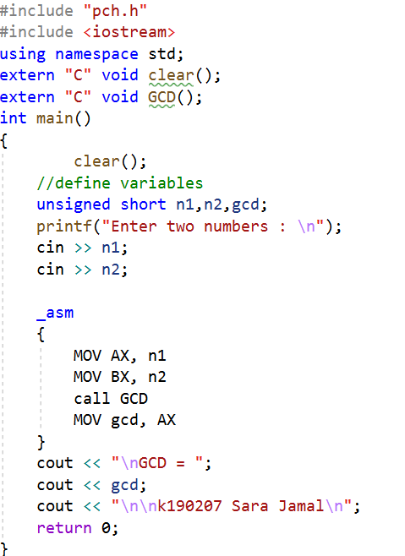 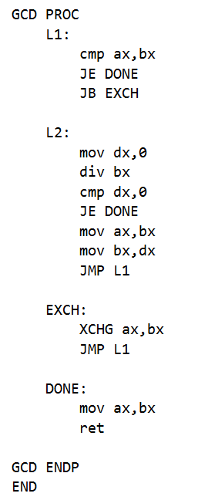

**Output:**

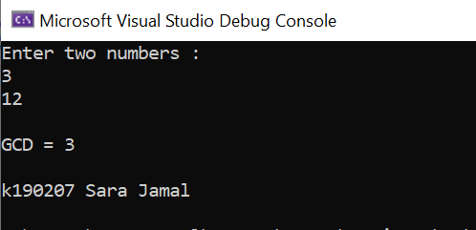

**Q2) Write a program in C++ which takes input from user and contains a procedure in assembly named ThreeAdd that displays the addition of three numeric parameters passed in a function argument.**

**Program:**

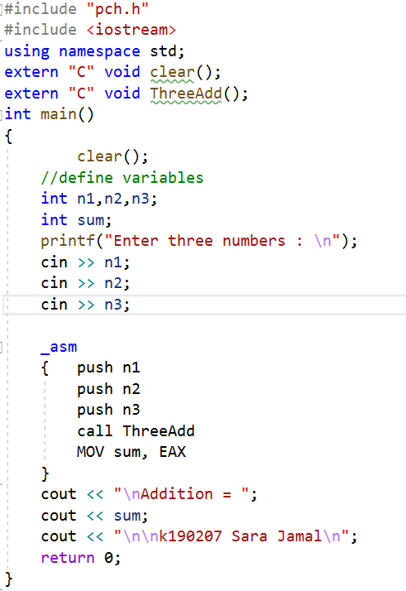 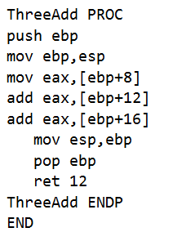

**Output:**

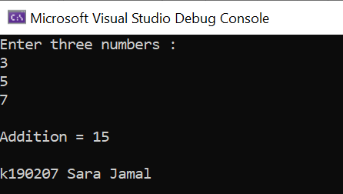

**Q3) Write a program in C++ which takes user defined input and implements binary multiplication using inline assembly code.**

**Program:**

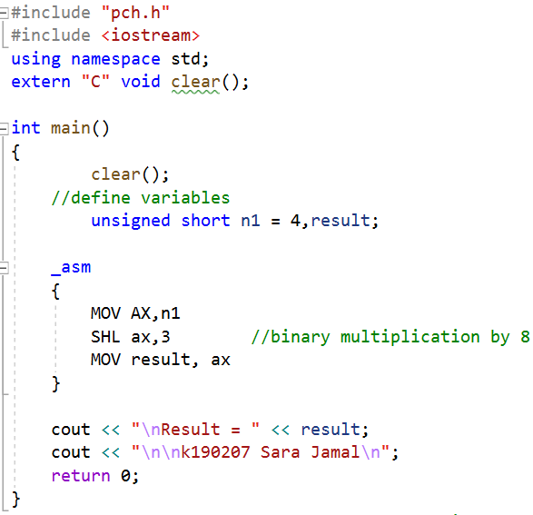

**Output:**

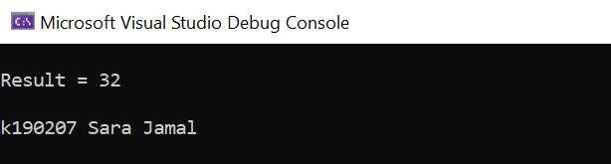

**Q4) Write a program in C++ which contains a procedure in assembly named MinMaxArray that displays the minimum &amp; maximum values in an array. Pass a size-10 array by reference to this procedure.**

**Program:**

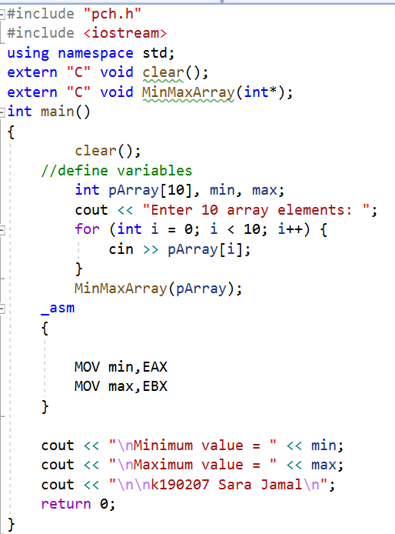 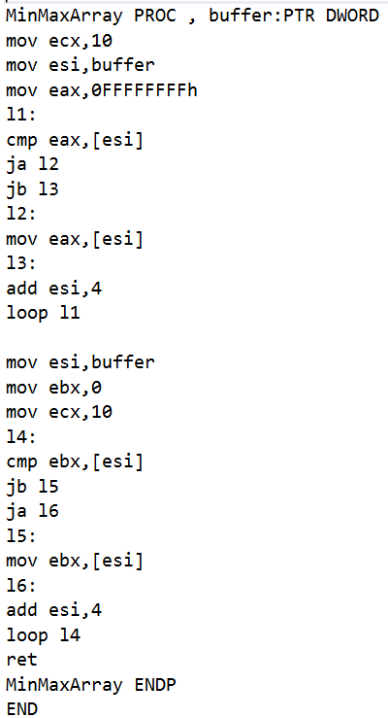

**Output:**

